Analysis and Insights
Monthly cost price difference – Taken top 6 high valued tickers (highest Volume* Close value) or company to understand the cost price deflection compared to the cost price of the start day.
Top 6 high valued sectors are:
Sector | Name | Sector | Industry
CNQ.TO | CDN NATURAL RES | Energy | Oil & Gas E&P
BMO.TO | BANK OF MONTREAL | Financial Services | Banks - Diversified
CM.TO | CANADIAN IMPERIAL BANK OF COMME | Financial Services | Banks - Diversified
CNR.TO | CANADIAN NATIONAL RAILWAY CO. | Industrials | Railroads
ABX.TO | BARRICK GOLD CORPORATION | Basic Materials | Gold
BNS.TO | BANK OF NOVA SCOTIA | Financial Services | Banks - Diversified
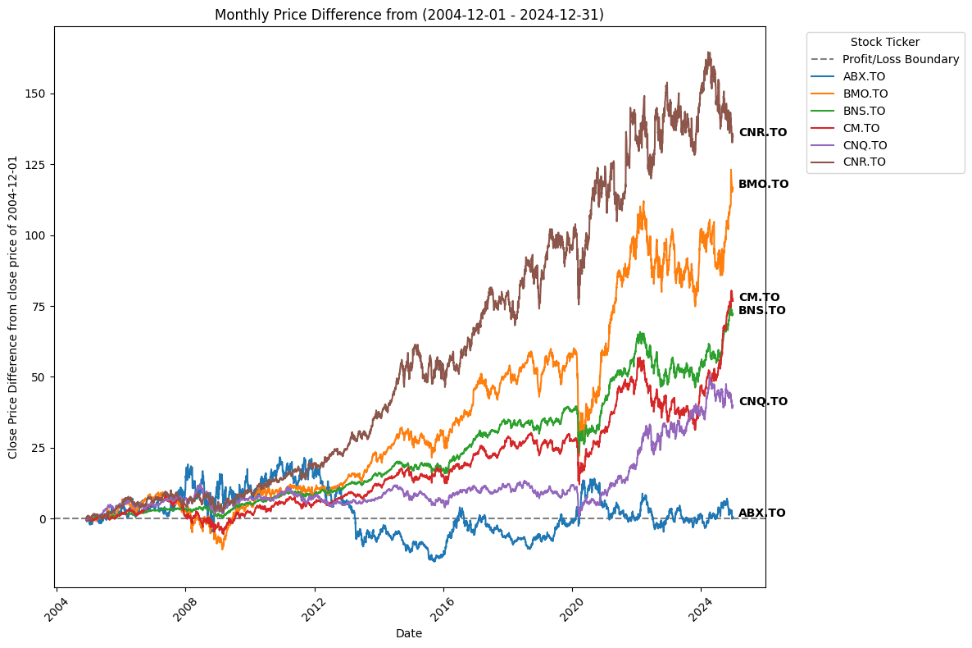
Observation from analysis:
- Sector which is highly valued are Oil & Gas E&P, Banks, Railway and Gold.
- Stock Growth Trends:
- The chart shows price differences from a base date (2004-12-01).
- Some stocks (like CNR.TO and BMO.TO) have experienced consistent long-term growth, making them strong candidates for stable investments.
- Others (like ABX.TO) have shown fluctuations, suggesting more volatility.
- Volatility and Risk:
- Stocks with higher price swings (e.g., ABX.TO) may be riskier but offer short-term trading opportunities.
- Stable stocks (e.g., CNR.TO) are more suited for long-term, low-risk investors.
- Investment Timing Matters:
- The 2008 and 2020 financial crises are visible as dips in stock prices.
- Investors who bought during these dips benefited from significant gains in the following years.
- Sector-Based Performance:
- Different stocks belong to different sectors.
- If a customer prefers low-risk investments, they should target sectors with steady upward trends.
- Profit/Loss Boundary (Dotted Line):
- It represents whether a stock is above or below its starting price.
- If a stock stays above the boundary for long periods, it indicates strong long-term performance.

How This Helps Beginner Investors:
Sector-Based Diversification to Reduce Risks:
- It means investing in different industries rather than putting all money into a single sector (e.g., technology, healthcare, finance).
- Different sectors react differently to economic changes, reducing overall investment risk.
Why is it important for new investors:
- If an investor only buys stocks from one sector (e.g., banking), their portfolio is at high risk if that sector crashes.
- Diversifying across multiple sectors protects against sector-specific downturns.
- For example:
Financial Sector (BMO.TO, CM.TO, BNS.TO) → Affected by interest rates, economic cycles.
Energy Sector (CNQ.TO) → Influenced by oil prices, geopolitical events.
Industrial Sector (CNR.TO) → Depends on trade, infrastructure growth.
Gold & Mining (ABX.TO) → Gains value in economic downturns (safe-haven investment).

How Can Beginners Use This?
- Scenario 1: If the economy slows down, banks (BMO.TO, CM.TO) might struggle, but gold (ABX.TO) could rise.
Scenario 2: If oil prices surge, energy stocks (CNQ.TO) will benefit, while transport (CNR.TO) may suffer due to higher costs.
- By investing across multiple sectors, losses in one area are balanced by gains in another.

